Kubernetes Task-6
- Create a ConfigMap from a directory containing multiple files and inject the variables into a pod as environment variables.
- Create a ConfigMap from a file and mount it as a volume inside a pod, ensuring the configuration data is available as files.
- Create a Secret with sensitive information (username and password) and inject it into a pod as environment variables.
- Create a Secret using a YAML file, mount it as a volume in a pod, and verify the specific Secret values are available as files.
- Inject a ConfigMap as environment variables and a Secret as files into the same pod, ensuring both are accessible within the pod.

- Create a directory with configuration files
mkdir app-configs
echo "DB_HOST=10.0.0.10" > app-configs/db_host.properties
echo "DB_PORT=3306" > app-configs/db_port.properties
echo "DB_NAME=mydatabase" > app-configs/db_name.properties
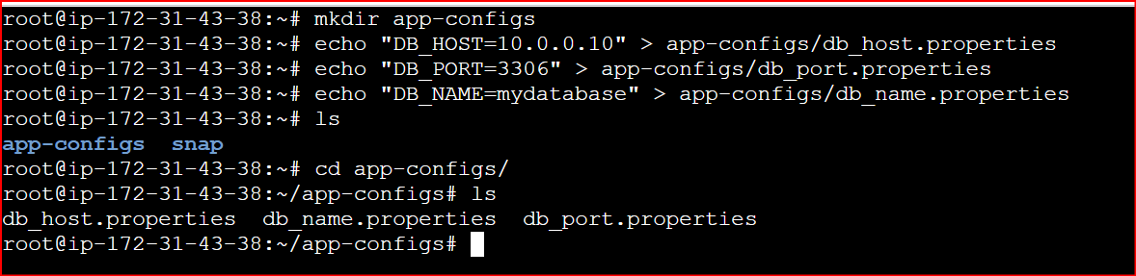
Create a ConfigMap from the directory
kubectl create configmap app-config --from-file=app-configs/
Verify it:
kubectl describe configmap app-config

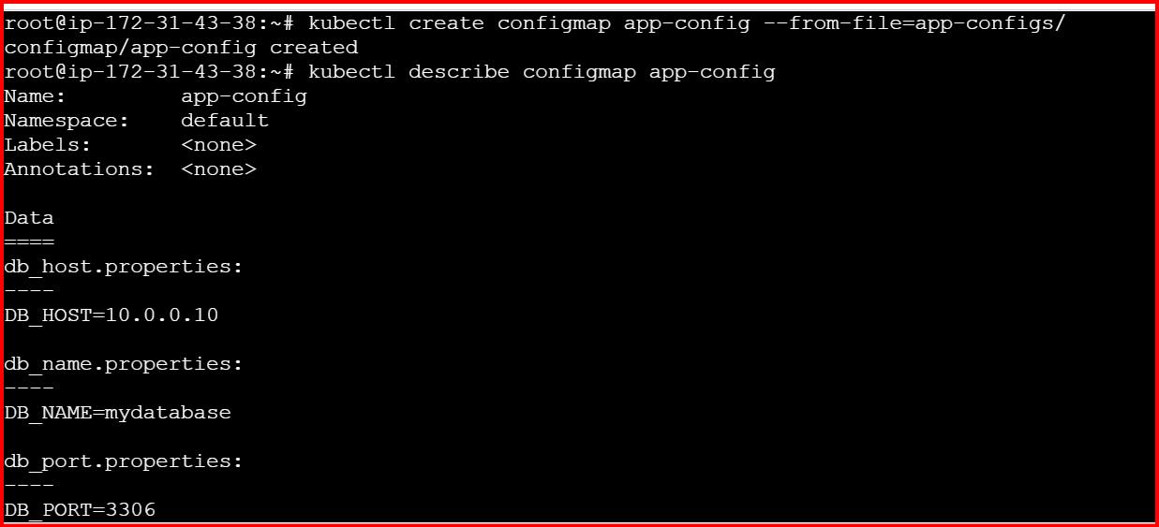
Create a Pod and inject ConfigMap as environment variables
Create a YAML file:
vi pod-configmap-env.yaml
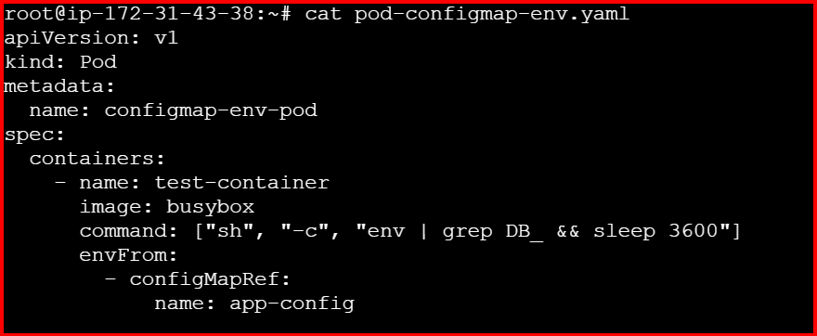
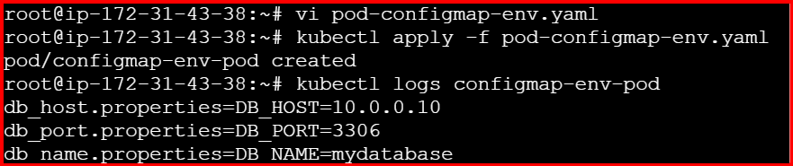

2.Create a ConfigMap from a file and mount it as a volume inside a pod, ensuring the configuration data is available as files.

Create a configuration file
echo "color=blue" > app.properties
You can also have multiple lines if needed:
echo "size=large" >> app.properties
echo "shape=circle" >> app.properties

Create a ConfigMap from the file
kubectl create configmap file-config --from-file=app.properties
Verify:
kubectl describe configmap file-config

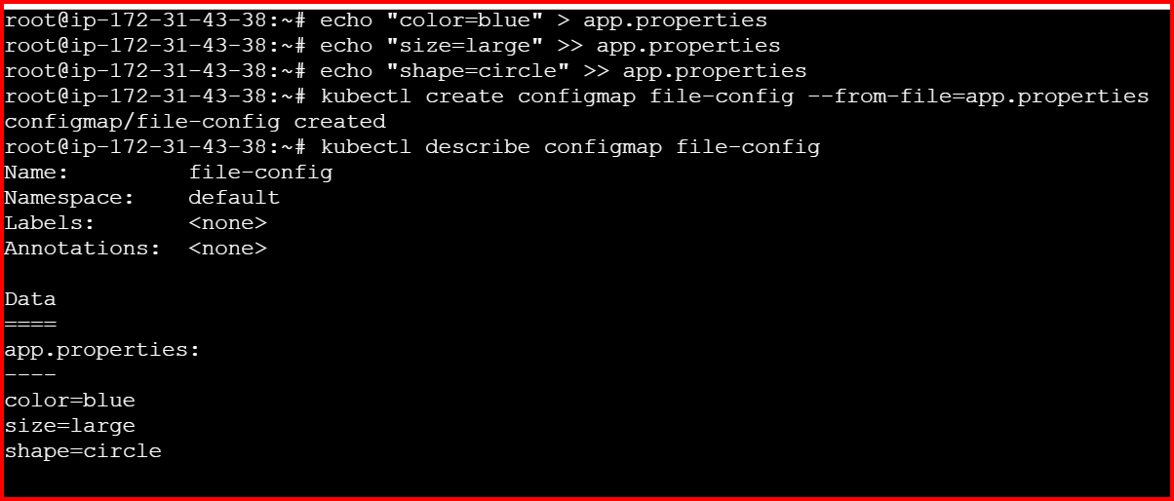

Create a Pod and mount the ConfigMap as a volume:
vi pod-configmap-volume.yaml
apiVersion: v1
kind: Pod
metadata:
name: configmap-volume-pod
spec:
containers:
- name: app-container
image: busybox
command: ["sh", "-c", "cat /etc/config/app.properties && sleep 3600"]
volumeMounts:
- name: config-volume
mountPath: /etc/config
volumes:
- name: config-volume
configMap:
name: file-config
kubectl apply -f pod-configmap-volume.yaml
Option 1: Check logs
Verify inside the Pod
kubectl logs configmap-volume-pod
kubectl get pods
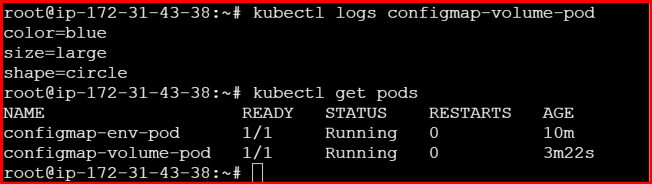
Option 2: Exec into the Pod shell
kubectl exec -it configmap-volume-pod – sh
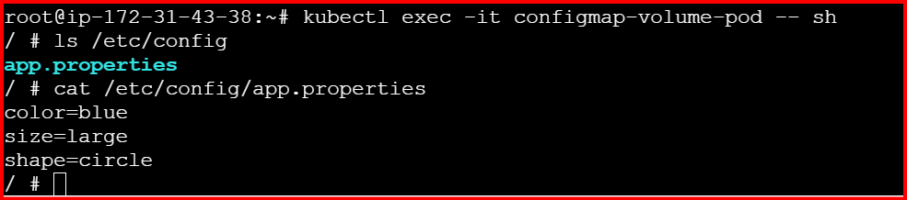

3.Create a Secret with sensitive information (username and password) and inject it into a pod as environment variables.
Step 1: Create the Secret
You can create a Secret with username and password directly via CLI:
kubectl create secret generic db-secret \
--from-literal=username=admin \
--from-literal=password=DevOps123
Verify:
kubectl describe secret db-secret
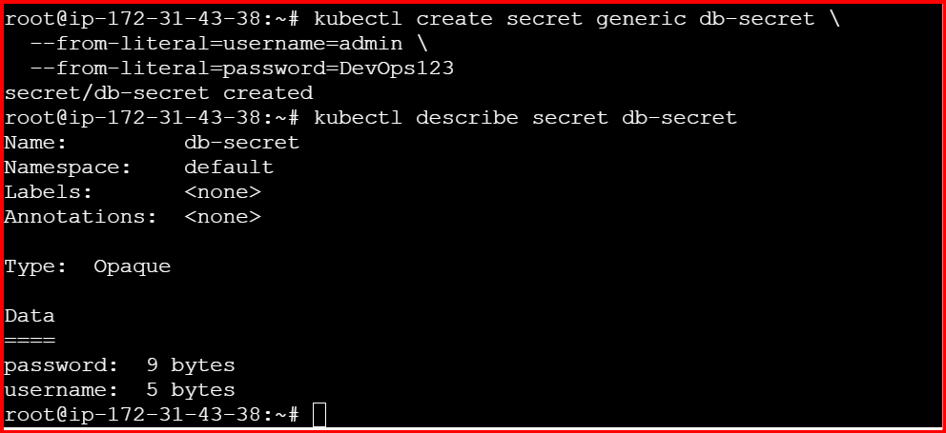

Step 2: Create a Pod and inject Secret as environment variables
vi pod-secret-env.yaml

apiVersion: v1
kind: Pod
metadata:
name: secret-env-pod
spec:
containers:
- name: app
image: busybox
command: ["sh", "-c", "echo User:$USERNAME Pass:$PASSWORD && sleep 3600"]
env:
- name: USERNAME
valueFrom:
secretKeyRef:
name: db-secret
key: username
- name: PASSWORD
valueFrom:
secretKeyRef:
name: db-secret
key: password

Apply the Pod YAML
kubectl apply -f pod-secret-env.yaml
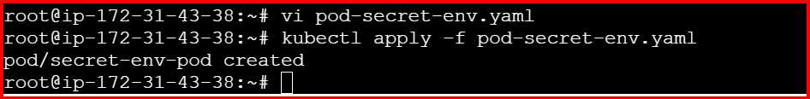
Verify logs
kubectl logs secret-env-pod
kubectl exec -it secret-env-pod -- sh
Inside Pod:
echo $USERNAME
echo $PASSWORD
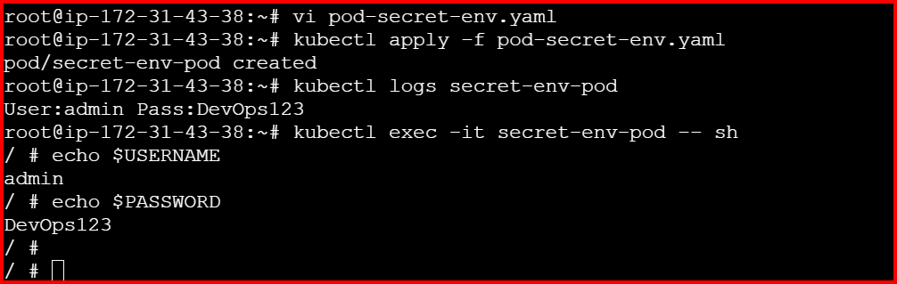

4.Create a Secret using a YAML file, mount it as a volume in a pod, and verify the specific Secret values are available as files.
Step 1: Create the Secret YAML
All Secret values must be base64 encoded. For example:
echo -n "admin" | base64
# Output: YWRtaW4=
echo -n "DevOps123" | base64
# Output: RGV2T3BzMTIz
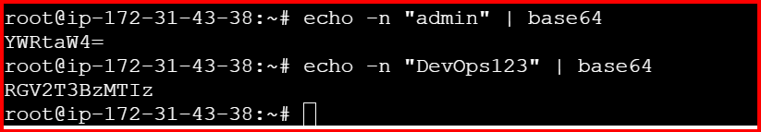
Now create the YAML:
vi db-secret-volume.yaml
apiVersion: v1
kind: Secret
metadata:
name: db-credentials
type: Opaque
data:
username: YWRtaW4= # base64 for "admin"
password: RGV2T3BzMTIz # base64 for "DevOps123"
apply the below commands
kubectl apply -f db-secret-volume.yaml
kubectl describe secret db-credentials
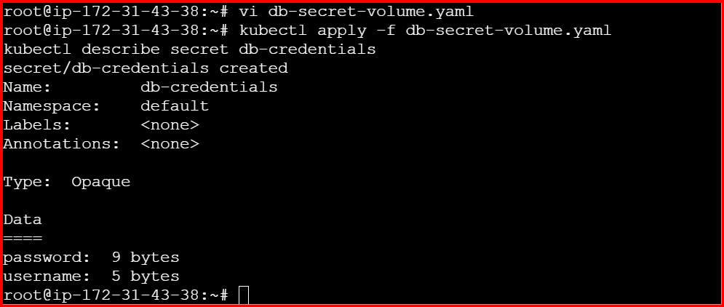

Step 2: Create a Pod YAML and mount Secret as a volume
vi pod-secret-volume.yaml

apiVersion: v1
kind: Pod
metadata:
name: secret-volume-pod
spec:
containers:
- name: app
image: busybox
command: ["sh", "-c", "ls /etc/secret-data && cat /etc/secret-data/username && cat /etc/secret-data/password && sleep 3600"]
volumeMounts:
- name: secret-vol
mountPath: /etc/secret-data
readOnly: true
volumes:
- name: secret-vol
secret:
secretName: db-credentials
Apply the command
kubectl apply -f pod-secret-volume.yaml

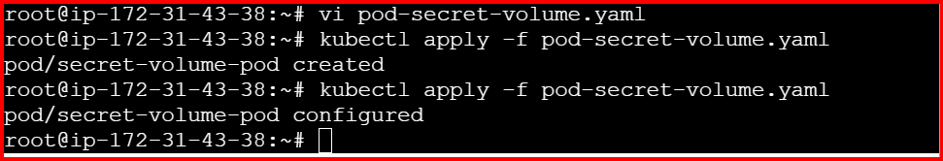
Verify inside the Pod
kubectl exec -it secret-volume-pod – sh
ls /etc/secret-data
cat /etc/secret-data/username
cat /etc/secret-data/password
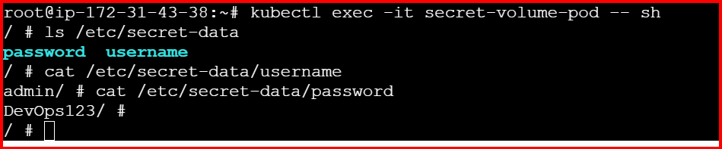

5.Inject a ConfigMap as environment variables and a Secret as files into the same pod, ensuring both are accessible within the pod.
Step 1: Prepare ConfigMap and Secret
ConfigMap (environment variables)
vi app-config.yaml
apiVersion: v1
kind: ConfigMap
metadata:
name: app-config
data:
DB_HOST: "10.0.0.10"
DB_PORT: "3306"
DB_NAME: "mydatabase"

kubectl apply -f app-config.yaml
Secret (mounted as files)
vi db-secret.yaml

apiVersion: v1
kind: Secret
metadata:
name: db-credentials
type: Opaque
data:
username: YWRtaW4= # base64 for "admin"
password: RGV2T3BzMTIz # base64 for "DevOps123"
kubectl apply -f db-secret.yaml
Step 2: Create the combined Pod YAML
vi pod-combined.yaml

apiVersion: v1
kind: Pod
metadata:
name: combined-pod
spec:
containers:
- name: app
image: busybox
command:
- sh
- -c
- |
echo "ConfigMap env variables:"
echo "DB_HOST=$DB_HOST"
echo "DB_PORT=$DB_PORT"
echo "DB_NAME=$DB_NAME"
echo ""
echo "Secret files:"
ls /etc/secret-data
cat /etc/secret-data/username
cat /etc/secret-data/password
sleep 3600
envFrom:
- configMapRef:
name: app-config
volumeMounts:
- name: secret-vol
mountPath: /etc/secret-data
readOnly: true
volumes:
- name: secret-vol
secret:
secretName: db-credentials

kubectl exec -it combined-pod – sh
Inside Pod:
env | grep DB_
ls /etc/secret-data
cat /etc/secret-data/username
cat /etc/secret-data/password

